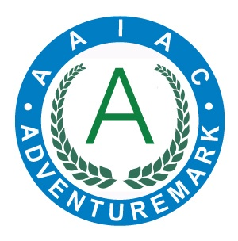
ADVENTUREMARK
www.adventuremark.co.uk
HIGH ADVENTURE OEC LTD
Has met the necessary standards for the safe delivery of
adventure activities as defined by the
Adventure Activities Industry Advisory Committee.

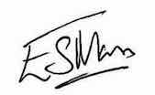
Elspeth Mason, Chair (AAIAC)

Abseiling | Jacobs Ladder
Archery | Kayaking
Artificial Climbing Wall | Leap of Faith
Bouldering | Low Ropes Courses
Bushcraft | Orienteering
Canoeing | Pot-Holing
Caving | Rock Climbing
Caving – Artificial | Rock Hopping
Crate Stacking | Sledging
Cycling (Road) | Stand Up Paddle Boarding
Gorge Walking | Swimming – pool, sea, natural waters
High Ropes Courses | Team Building
Hill Walking | Weaselling
Improvised Rafting | Zip Wires

Date Issued : 18th December 2024 | Expiry Date : 18th December 2026
Certificate No : AAA101428

